DESIGN OPTIMIZATION AND ANALYSIS OF 3D POWDER MIXER
B. Tech. Phase II Major Project Report submitted in partial fulfilment of the requirements for the degree of
Bachelor of Technology (B. Tech.)
In
MECHANICAL ENGINEERING
By
Vikram Jayanta Sahoo EU1235004
Sahil Sudesh Kini EU1235007
Rachana Jaisram Verma EU1235013
Under the guidance of
Mr. Avinash Chavan
Project Guide
Mr. Pratap Desai
Sr. Manager – Machine Design & Development
Project Guide from Industry


Department of Mechanical Engineering
St. John College of Engineering and Management, Palghar
Autonomous Institute
University of Mumbai

2026 – 2027
CERTIFICATE
This is to certify that the B.E. project entitled “Design Optimization and Analysis of 3D Powder Mixer” is a bonafide work of “Vikram Jayanta Sahoo” (EU1235004), “Sahil Sudesh Kini” (EU1235007) and “Rachana Jaisram Verma” (EU1235013) submitted to University of Mumbai in partial fulfilment of the requirement for the award of the degree of “Bachelor of Technology” in “Mechanical Engineering” during the academic year 2026 – 2027.

Mr. Avinash Chavan  Project Guide | Mr. Pratap Desai  Sr. Manager – Machine Design & Development  Project Guide from Industry
Dr. Kishor Rambad  Head of Department |  | Dr. Kamal Shah  Principal
Date: ______________
Place: Palghar

B.E. PROJECT REPORT APPROVAL
This project report entitled Design Optimization and Analysis of 3D Powder Mixer by Vikram Jayanta Sahoo, Sahil Sudesh Kini and Rachana Jaisram Verma is approved for the degree of Bachelor of Technology in Mechanical Engineering from University of Mumbai.
Examiners
1. ____________________________________
2. ____________________________________
Date:
Place:

DECLARATION
We declare that this written submission represents our ideas in our own words and where others’ ideas or words have been included, we have adequately cited and referenced the original sources. We also declare that we have adhered to all principles of academic honesty and integrity and have not misrepresented or fabricated or falsified any idea/data/fact/source in our submission. We understand that any violation of the above will be cause for disciplinary action by the Institute and can also evoke penal action from the sources which have thus not been properly cited or from whom proper permission has not been taken when needed.
---------------------------------
Signature
Vikram Jayanta Sahoo (EU1235004)
---------------------------------
Signature
Sahil Sudesh Kini (EU1235007)
---------------------------------
Signature
Rachana Jaisram Verma (EU1235013)
Date:

ACKNOWLEDGEMENT
We sincerely thank Mr. Avinash Chavan, our project guide from the Department of Mechanical Engineering, St. John College of Engineering and Management, Palghar, for his guidance and support throughout this work.
We are grateful to Custom Capsule Pvt. Ltd. for assigning this project and providing the CAD model and physical prototype for analysis and design optimization. We thank Mr. Raj Vikram Tahil, Director, and Mr. Santosh Bhagat, Plant Head, for their support. We especially thank Mr. Pratap Desai, Senior Manager – Machine Design & Development, who also served as our project guide from the company, for his technical guidance and suggestions.
We also thank our faculty members and the department for their suggestions and for providing the facilities used for CAD modelling and analysis.

Place: Palghar
Date: ____________
Name & Signature of the Candidates
Vikram Jayanta Sahoo
Sahil Sudesh Kini
Rachana Jaisram Verma

ABSTRACT
This report presents the redesign and dynamic study of a 3D powder mixer. The mixer holds a jar in a cage. Two shafts and a set of links move the cage. The earlier mechanism had three faults. One shaft moved on a small circle. The cage jerk was high. The links also passed dead-centre, or singular, positions at about 128° to 135° and 315° to 328° of drive rotation. These two regions are about 180° apart. Additional links were removed to make a new mechanism, by connecting the Y links directly to the cage. The new set-up is very similar to the layout used with the Schatz linkage, which has five links that can be moved. We verified the spacing of the shaft by the Schatz relation Ls = a√3.
The CAD shaft spacing of 242.4 mm yields a = 140 mm. ANSYS Rigid Dynamics was used for the transient analysis with a drive speed of 1.57 rad/s. The results were used to calculate the cage jerk. The peak cage jerk decreased from 7107.406 to 3464.010 mm/s³, a 51.26% reduction. The greatest cage acceleration has dropped from 2597.9 mm/s2 to 1335.0 mm/s2. The moving mass is about 10% higher. In this study a rigid body model is assumed. Does not indicate lower stress or better mixing. A complete contact model and prototype test needs to be done thereafter.
TABLE OF CONTENTS
 | Abstract | vi
 | List of Figures | ix
 | List of Tables | x
 | List of Abbreviations | xi
Chapter 1 | Introduction | 1
 | 1.1 Motivation | 1
 | 1.2 Problem Statement | 2
 | 1.3 Objectives | 3
 | 1.4 Scope | 3
Chapter 2 | Review of Literature | 5
 | 2.1 3d-motion Mixers | 5
 | 2.2 Evaluation of Powder Mixing | 5
 | 2.3 Simulation of Blend Uniformity | 5
 | 2.4 Jerk in Multibody Dynamics | 6
 | 2.5 Schatz Linkage and Design Relations | 6
 | 2.6 Theoretical Background | 7
 | 2.7 Research Gap | 7
Chapter 3 | Requirement Analysis | 10
 | 3.1 Hardware Requirements | 10
 | 3.2 Software Requirements | 11
 | 3.3 Functional Requirements | 11
 | 3.4 Non-functional Requirements | 12
Chapter 4 | Design | 13
 | 4.1 Mechanism Layout | 13
 | 4.2 Joint Design | 14
 | 4.2.1 Purpose of Each Joint Type | 14
 | 4.3 Design Relations and Dimensions | 14
 | 4.4 Kinematic Correction | 16
 | 4.5 Modelling Assumptions | 17
 | 4.6 Calculation Method | 17
 | 4.7 Workflow Diagram | 18
 | 4.8 Work Breakdown Structure (WBS) Chart | 19
Chapter 5 | Report on Present Investigation | 20
 | 5.1 Proposed System | 20
 | 5.1.1 Algorithm and Process Design | 20
 | 5.1.2 Block Diagram of Proposed System | 20
 | 5.2 Implementation | 21
 | 5.2.1 ANSYS Model Setup | 21
 | 5.2.2 Transient Settings | 22
 | 5.2.3 Output of the Analysis With Description | 22
 | 5.3 Numerical Stability of the Modified Model | 24
 | 5.4 Contact and Kinematic Check | 24
Chapter 6 | Result and Discussion | 26
 | 6.1 Kinematic Behaviour | 26
 | 6.2 Jerk Comparison | 26
 | 6.3 Limitations and Engineering Meaning | 28
 | 6.4 Objective-wise Summary | 29
Chapter 7 | Conclusion and Future Work | 30
 | 7.1 Conclusion | 30
 | 7.2 Future Work | 30
 | References (at the end of every chapter) | 31
 | Appendix A: Key ANSYS Data and Result Sheets | 32
 | Appendix B: Glossary of Terms | 35
 | List of Publications | 36
 | Plagiarism Report | 37
 | Acknowledgement | v

LIST OF FIGURES
Fig. No. | Figure Name | Page No.
1.1 | Shaft motion in the earlier model and in the modified model (schematic) | 2
2.1 | Relation between position, velocity, acceleration and jerk | 6
4.1 | ANSYS model views: (a) earlier mechanism, (b) modified mechanism | 13
4.2 | Dimension relations of the Schatz linkage used in the design (schematic) | 15
4.3 | Project workflow | 18
4.4 | Work breakdown structure of the project | 19
5.1 | Block diagram of bodies and joints in the modified mechanism | 21
5.2 | Total cage acceleration against drive angle | 22
5.3 | Cage jerk against drive angle | 23
5.4 | Peak cage acceleration and peak cage jerk of the two models | 24
6.1 | Reduction of peak acceleration and peak jerk | 27
A.1 | ANSYS result sheet of the earlier model | 33
A.2 | ANSYS result sheet of the modified model | 34

LIST OF TABLES
Table No. | Table Name | Page No.
2.1 | Summary of the reviewed sources | 8
3.1 | Workstation used for CAD and analysis | 10
3.2 | Main component groups of the mixer model | 10
3.3 | Software and analysis requirements | 11
3.4 | Structural Steel data used in the model | 11
3.5 | Functional requirements | 12
3.6 | Non-functional requirements and checks | 12
4.1 | Joint arrangement of the modified model | 14
4.2 | Dimension check of the modified mechanism | 15
4.3 | Size and mass of the two models | 16
4.4 | Comparison of the earlier and the modified model | 17
5.1 | ANSYS setup of the modified model | 21
5.2 | Transient analysis settings | 22
5.3 | Cage acceleration and jerk | 23
5.4 | Solver results of the modified model | 24
6.1 | Result comparison of the two models | 26
6.2 | Cage acceleration and jerk inside the dead-centre windows | 27
6.3 | Size-normalised acceleration and jerk | 28
6.4 | Objectives and results | 29
A.1 | Key ANSYS data | 32
B.1 | Glossary of terms | 35

LIST OF ABBREVIATIONS
Abbreviation | Meaning
3D | Three Dimensional
ANSYS | Analysis System (simulation software)
BOM | Bill of Materials
CAD | Computer-Aided Design
DEM | Discrete Element Method
PID | Project Identification Number
RBD | Rigid Body Dynamics
RK4 | Runge-Kutta method of fourth order
rpm | Revolutions per minute

LIST OF SYMBOLS
Symbol | Meaning | Unit
a | Acceleration (Chapters 2, 4, 5, 6) | mm/s²
a | Centre-distance unit of the Schatz linkage (Section 4.3) | mm
F | Force | N
h | Time step of the solver | s
j | Jerk | mm/s³
Ls | Distance between the two shaft axes | mm
m | Mass | kg
t | Time | s
θ | Drive angle, θ = ωt | degree
ω | Drive speed (1.57 rad/s) | rad/s

CHAPTER 1

INTRODUCTION
All the CAD model and data was provided by Custom Capsule Pvt. Ltd. who had assigned this project. physical prototype. The work is mainly dedicated to the analysis of the existing mixer mechanism, Identification of the source of high cage jerks, and optimizing the design to achieve smoother cage motion. Powder is stored in a closed jar in a 3D powder mixer. It carries the jar away from itself in more than one manner. direction at the same time. The jar rotates and also changes its orientation. Because of this, the powder is not layered. It wraps around itself, and the particles transmutate. places. Hence, 3D mixers are widely used in pharmaceutical, food and chemical industries. That is the reason why 3D mixers are the common trend in the industries.
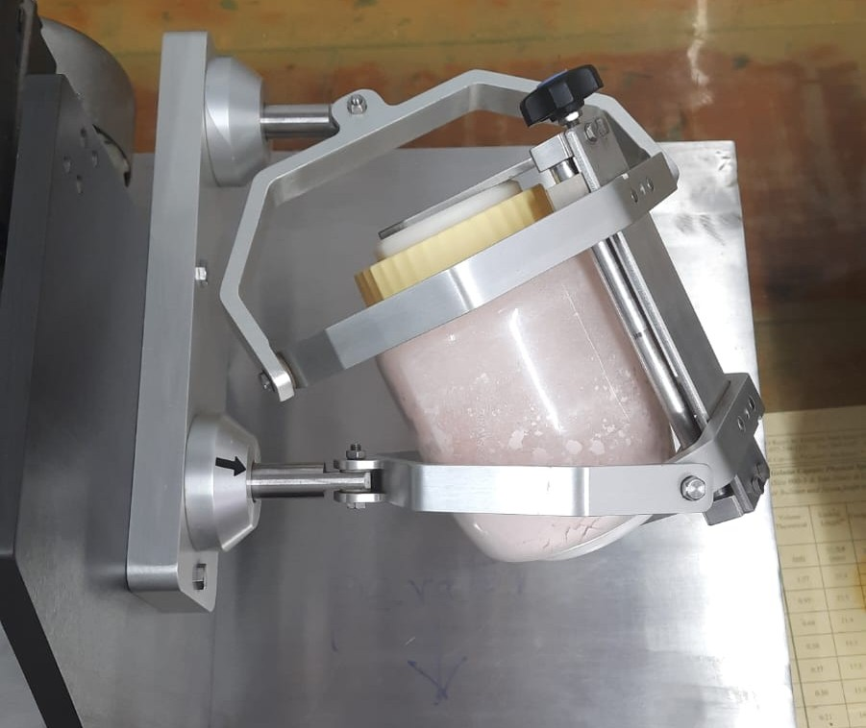
Figure 1.1: Physical prototype of the 3D powder mixer
This project deals with the machine and not the powder. The jar is placed inside a cage which is driven along a set of shafts and links. The route of the mechanism has to be the desired route. Therefore, we first investigated its kinematic behavior. The former kind demonstrated large cage jerk. One shaft also shifted in an orbit, rather than rotated about the center line.
The links reached the dead center positions 2 times in every turn. We stripped two links, and linked the Y links directly to the cage and recalculated the dynamic analysis in ANSYS. The effects of both designs were compared using jerk (the rate of change of acceleration).
The earlier mechanism had high cage jerk. One shaft moved on a small circle, and the links reached dead-centre positions twice per turn. We removed two extra links, connected the Y links directly to the cage, and repeated the dynamic analysis in ANSYS. We used jerk, the rate of change of acceleration, to compare the two designs.

1.1 MOTIVATION

A tumble mixer is simple in design that rotates a jar around one axis. The powder particles mix together while cascading through the system and in some sections are moving slowly. A 3D mixer introduces another motion to add to these, enhancing mixing. There is an added motion, however that makes the mechanism a bit more complicated. A 3D mixer makes the jar go on a varying path. Forces are now acting on the jar and the contents of the cage, due to the cage's acceleration. Rapid acceleration changes may cause vibration and shock at the joints and bearings. This abrupt change is measured in terms of jerk by engineers. Reducing peak of jerks is generally smoother motion.

The other issue is when the mechanism is in a dead-center or singular position. These locations can be such that the links are parallel, so that the output is difficult to control. Non-linearities in the output motion can lead to shaking when slight changes in input motion are made. Existing mixer mechanism was found to have such positions. The results obtained from simulations are subject to the same risk of misrepresentation. Another model, where a shaft was given a small circular path, showed that this was not sufficient to give the correct overall motion. This result demonstrated that the simulated movement does not completely correspond to the real machine. The target was to create an efficient mechanism which has an centre-line turn around with minimum dead-center positions, less jerk. Cage jerk was chosen as the primary criterion to evaluate the various designs.

1.2 PROBLEM STATEMENT
The earlier mixer mechanism had three linked problems.
- 1.The original mixing action problem had three interwoven issues. The cage jerk was a high cage. The acceleration of the cage is about 2597.9 mm/s2, while the peak Jerk of the cage is 7107.406 mm/s3.

- The mechanism went through what is known as dead-center, or singular, positions. The main ranges were about 128° to 135° and 315° to 328° of drive rotation. The fault is repeated twice, depending on the area of the periodical projection, as the two areas are approximately 180° to one another. The most significant accelerations and jolts of the old cage occurred near these locations.

- One shaft had unexpected circular or "orbital" movement. Left freely swinging on the axis of its center line. 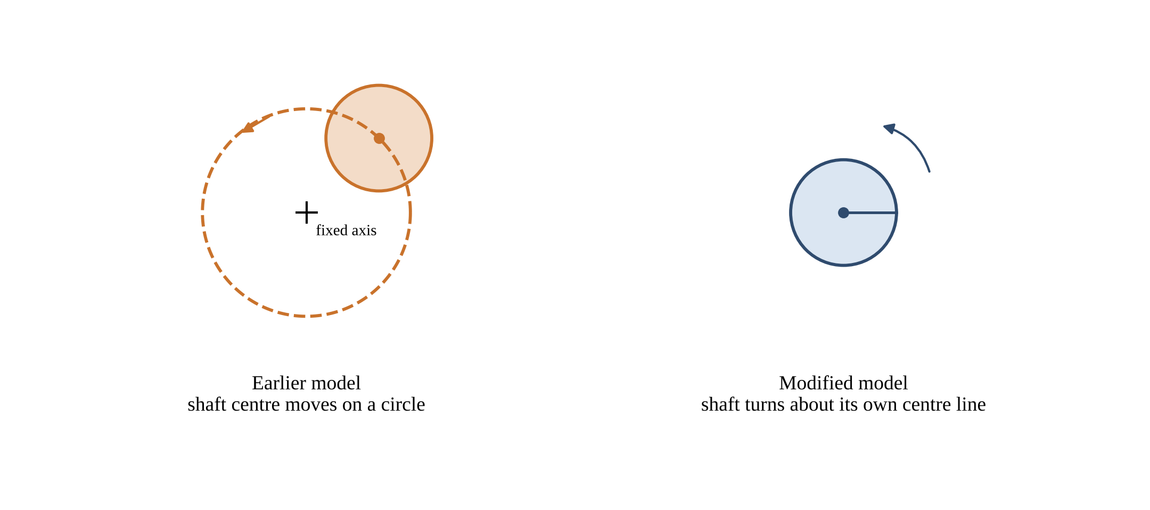
Figure 1.2: Shaft motion in the earlier model and in the modified model (schematic)

This was due to link layout. There were two additional joints between the cage and the shafts. They introduced intermediate joints and opened up a way of alignment that gave the dead center areas. The objective is to make it easier to arrange the links; eliminate dead center and unwanted orbit of the shaft; and perform an analysis to see if the cage acceleration and jerk has been reduced in the new arrangement.

1.3 OBJECTIVES
The aim of the project is to optimize the mixer mechanism and to compare its dynamic response with that of the earlier design. The following targets were known as aims, and these are set to be achieved:
- For the earlier mechanism explain why the cage jerk was high and the explanation of the dead center regions.
- Make a new mechanism by removing two extra links and connecting the Y links directly to the cage.
- Comply with key dimensions of the new mechanism, based on the Schatz relations.
- Correct the shaft kinematics, and align every revolute axis with the real shaft and pin centre lines.
- Run transient rigid-body analyses of both mechanisms in ANSYS.
The project covers the CAD-based mechanism, joint definitions, transient rigid-body analysis, and comparison of cage acceleration and jerk. The CAD model and physical prototype supplied by the company formed the basis of the study. ANSYS Rigid Dynamics was used for the analysis.

1.4 SCOPE
The work includes the CAD-based mechanism model, joint definitions, a transient rigid-body analysis, and a comparison of the acceleration of a cage and the cage "jerk. The study is based on the provided CAD model and physical prototype. ANSYS Rigid Dynamics is used for the dynamic analysis.
There are some subjects that aren't covered. The individual powder particles are not simulated. Stress and bearing load/fatigue life are not calculated. A test is not used to measure mixing uniformity. The report repeats the limits to the places where they are applicable, so the reader won't take any interpretation beyond what is available.
The report has seven chapters. In chapter 2, literature review related work and the Schatz linkage are conducted. Chapter 3 lists the requirements. The design and the dimension relations are explained in chapter 4. The setup for the analysis and the results are provided in chapter 5. Results and limitations of the chapter are discussed in chapter 6. In conclusion and future work parts, shown in Chapter 7 of the thesis one can elaborate on further research and development needs.
REFERENCES
[1] H. J. Sommer III, “Kinematic jerk and jounce for multibody dynamics with joint constraints,” Mechanism and Machine Theory, Vol. 196, Art. No. 105613, 2024. DOI: 10.1016/j.mechmachtheory.2024.105613.
[2] R. L. Norton, Design of Machinery, McGraw-Hill, 5th Edition, 2012.

CHAPTER 2

REVIEW OF LITERATURE

We considered the five subject areas listed below: 3D-motion mixers, evaluation of powder mixing, simulation of blend uniformity, jerk in multibody systems and Schatz linkage. The project is an MEChanism Project. As a consequence, we are not directly responsible to CAD models published/republished by others. The papers are used as reference to contextualize and as principles of design direction.

2.1 3D-MOTION MIXERS

In a 3D-motion mixer, a 3D version of the Schatz mechanism is used, as reviewed by Bhoite, Kakandikar and Nandedkar. The review demonstrates combination of rotation, translation and inversion of a container. This creates powder flow in a lot of directions and not a one-directional path.

This is the type of motion that our mixer must give. The paper helps us to understand what the cage must do. It is a review. Does not return the result to be displayed as a dynamic result for our CAD modeling; it is not used as such.

2.2 EVALUATION OF POWDER MIXING

Asachi, Nourafkan and Hassanpour examine the methods which engineers use to determine the quality of a powder mix [2]. They demonstrate how the mixing action influences particle flow and uniformity of the mixture.

These are techniques applied to powder. They do not observe the container-moving machine. This can be helpfully used for our work in one way. It gives us information about the movement that is input into the mixing process. It becomes a good starting point for a better blend because a good container motion is closely associated with a good blend.

2.3 SIMULATION OF BLEND UNIFORMITY

In Sustainable Crop Production, the student will simulate blend uniformity in their capstone project.

The discrete element method is the method used by Florian-Algarin and Méndez to study the blend uniformity and powder behavior in a continuous tumble mixer [3]. In this method a computer follows each particle. The method provides information about detail inside the container but requires an input container motion.

Our project provides that type of input in an easy manner. Cage motion is examined to ensure it meets the following criteria: correct and smooth. Then a subsequent DEM can utilize the corrected motion. The DEM will NOT be run in this report.

2.4 JERK IN MULTIBODY DYNAMICS
The first derivative of the acceleration is the jerk. Sommer presents a way to compute the kinematic jerk and jounce for multibody systems with joint constraints [4]. Jerk is correlated to force changes and with vibration excitation. A mechanism that has a large jerk will apply sudden changes of force to its joints.

Jerk is also considered as a design limit in machine design texts. When Norton refers to the motion of cam followers [5] he uses it too. The same is done for the cage of the mixer. The relationship between jerk and the other motion quantities are illustrated in figure 2.1. The steps are just one time derivative of the previous step.
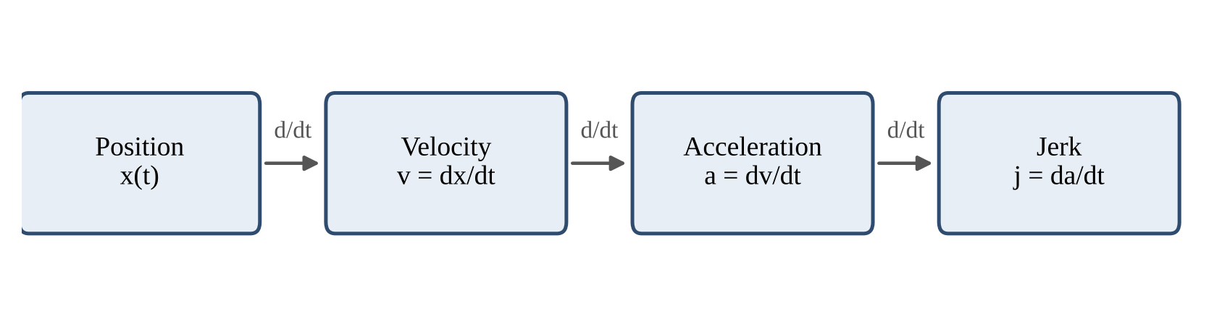
Figure 2.1: Relation between position, velocity, acceleration and jerk

2.5 SCHATZ LINKAGE AND DESIGN RELATIONS

The Schatz linkage is a closed-chain spatial linkage that is composed from revolute joints. It has five movable links [1] with one fixed [2]. The motion is a mixture of rotation and inversion, and a container in the output link moves in 3D. This is the reason why it is good for a powder mixer.

The linkage is a constant geometric ratio. The center distance between the revolute joints of the two links in each gripper is equal to the center distance between the related revolute joints of the cage. This distance is called a. The center distance between the two shaft axes is then Ls = a√3, which is about 1.732a. The material to be mixed is in the container and the 3D motion is given through the cage to the container.

These relationships are helpful in the design process. They relate the spacing of the shafts and link joints to a single dimension. We don't make one choice for each dimension. The same is demonstrated by Zalyubovskyi and co-authors for a tumbling machine with a spatial mechanism. They choose rational geometric parameters and eliminate passive constraints to increase reliability [6].

2.6 THEORETICAL BACKGROUND
Rigid-body dynamics. Rigid body model – each part maintains its form. The solver does not keep track of deformation. It is able to compute the motion of each body from the joints and the inertia. A run is swift; a study of motion is suitable for the model. No two models will be the same in terms of stress.
Joints and degrees of freedom. There are 6 degrees of freedom of a free rigid body in space. A revolute joint is a joint that only allows one rotation on one axis. If the joint doesn't move, then there's no flexibility. Even a body with the correct number of joints can have incorrect axis of the joints that affect the path of the body. This is the fault that we encountered in the previous model..
Dead centre. A dead centre, or singular position, occurs when links line up. The driving link then cannot move the driven link in a controlled way. The ratio of output motion to input motion becomes very sensitive. Near such a position, the output acceleration can rise sharply for a small change of the input angle [5].
Numerical integration. ANSYS Rigid Dynamics solves the equations of motion in small steps of time. The solver log of our model states the Runge-Kutta 4 method (RK4). In each step, RK4 finds the slope four times and combines the four values as a weighted average [7]. Equation (2.1) gives the update from step n to step n+1, where h is the time step.
yₙ₊₁ = yₙ + (h/6)(k₁ + 2k₂ + 2k₃ + k₄) (2.1)
With auto time stepping on, the solver changes h by itself. It varies in size with the speed of the motion and scales to h when it is rapid, and to large when it is slow.
2.7 RESEARCH GAP
Most studies on powder mixing are directed towards the behavior of the particles or uniformity. Very few of them monitor the actual rotation of the mixer. Table 2.1 summarizes what we learn from each source and what is not included in the source.
Ref. | Subject | Used in this project for
[1] | Schatz mechanism and 3D-motion mixers | Type of motion and link structure
[2] | Techniques to evaluate powder mixing | Link between container motion and blend
[3] | DEM study of blend uniformity | Idea of a later particle study
[4] | Kinematic jerk with joint constraints | Definition and meaning of jerk
[5] | Machine design: cams, dead centres, joints | Jerk limit and dead-centre theory
[6] | Tumbling machine with spatial mechanism | Geometry chosen by relations; passive constraints removed
Table 2.1: Summary of the reviewed sources
This is evident from the table. No source compares the cage jerk of two mixer mechanisms near their dead-centre angles. We use cage jerk as a simple mechanical design measure. We apply it to a mechanism with a clear fault and to its corrected version.
We also keep the comparison at one physical component. Probe numbers can change between models, so we do not compare by probe name. We compare the cage, where the jar sits.
REFERENCES
[1] K. Bhoite, G. M. Kakandikar and V. M. Nandedkar, “Schatz Mechanism with 3D-Motion Mixer—A Review,” Materials Today: Proceedings, 2015. DOI: 10.1016/j.matpr.2015.07.003.
[2] M. Asachi, E. Nourafkan and A. Hassanpour, “A review of current techniques for the evaluation of powder mixing,” Advanced Powder Technology, Vol. 29, Issue 7, Page 1525-1549, 2018.
[3] M. Florian-Algarin and R. Méndez, “Blend uniformity and powder phenomena inside the continuous tumble mixer using DEM simulations,” AIChE Journal, 2015. DOI: 10.1002/aic.14694.
[4] H. J. Sommer III, “Kinematic jerk and jounce for multibody dynamics with joint constraints,” Mechanism and Machine Theory, Vol. 196, Art. No. 105613, 2024.
[5] R. L. Norton, Design of Machinery, McGraw-Hill, 5th Edition, 2012.
[6] M. Zalyubovskyi, O. Volianyk, M. Rubanka, S. Koshel, H. Koshel and S. Popovichenko, “Design of a tumbling machine (mixer) using a statically determinate spatial mechanism and determination of rational geometric parameters,” Eastern-European Journal of Enterprise Technologies, Vol. 1, No. 7(139), 2026. DOI: 10.15587/1729-4061.2026.352115.
[7] S. C. Chapra and R. P. Canale, Numerical Methods for Engineers, McGraw-Hill, 7th Edition, 2015.

This project was run on the CAD and the ANSYS analysis was performed on the workstation. The prototype of the mixer supplied by the company was used as a physical reference for the model. The main computer requirements and the run time of the solvers obtained in the ANSYS reports are shown in Table 3.1.

REQUIREMENT ANALYSIS

Table 3.1 shows the workstation requirements. Table 3.2 shows the main components of the mixer model. The bearings and fastenings acquired are not covered in detail, due to this project being on mechanism motion and simulation.

3.1 HARDWARE REQUIREMENTS
Two types of hardware are important for this project. The first is the computer that ran the CAD and ANSYS work. The second is the mixer prototype that the model represents. Table 3.1 gives the workstation items. The solver run times come from the ANSYS reports. The team fills in the other values before the final print.
Item | Value
Processor | AMD Ryzen or Intel Core
Installed memory (RAM) | 16 GB
Graphics card | NVIDIA RTX 3050 or above
Operating system | Windows
Solver run time, 4 s transient (earlier model) | 0.142 s (RBD elapsed time)
Solver run time, 4 s transient (modified model) | 0.279 s (RBD elapsed time)
Table 3.1: Workstation used for CAD and analysis
The prototype has the main groups of parts that Table 3.2 lists. We do not give the details of purchased hardware, such as bearings and fasteners. The current work shows the motion of the mechanism and its simulation.
Component group | Function
Plate (ground) | Gives the fixed reference for the mechanism
Shaft 2 and new shaft 1 | Give the two rotating input paths
Y links (two) | Move the motion from the shafts directly to the cage
Cage | Holds the jar and receives the mechanism motion
Support parts (two) | Stay fixed to the cage
Joints | Set the relative motion between connected bodies
Table 3.2: Main component groups of the mixer model

3.2 SOFTWARE REQUIREMENTS
The CAD model is done in SolidWorks. The Parasolid file is read into ANSYS using the geometry. The dynamic study is performed with the Rigid Dynamics solver of ANSYS Mechanical, R1 2026. The software items and the software used is provided in table 3.3.
Item | Requirement | Use in the project
CAD | SolidWorks model | Create and update the mixer geometry
Geometry exchange | Parasolid import | Move the model into ANSYS
Dynamic solver | ANSYS Rigid Dynamics | Simulate the motion of the mechanism
Analysis type | Transient rigid-body dynamics | Study the motion over time
Integration | Runge-Kutta 4 (solver log) | Solve the equations of motion
Input | Rotational velocity | Drive one revolute joint
Output | Acceleration and related results | Calculate cage jerk
Table 3.3: Software and analysis requirements
The unit system used is mm, kg, N and s. The rotation is in rad/s. The end time of the step is 4 s. The model is constructed with the use of Structural Steel. The material values from the ANSYS report are presented in table 3.4. The elastic values will not be used in a rigid-body study. The table contains a record of the model which can be used in a subsequent study using a flexible body.
Property | Value
Density | 7.85 × 10⁻⁶ kg/mm³
Young’s modulus | 2.00 × 10⁵ MPa
Poisson’s ratio | 0.30
Shear modulus | 76,923 MPa
Tensile yield strength | 250 MPa
Tensile ultimate strength | 460 MPa
Compressive yield strength | 250 MPa
Table 3.4: Structural Steel data used in the model

3.3 FUNCTIONAL REQUIREMENTS
The functional requirements describe the behavior that the model must exhibit. They don't tell how the solver did it. Table 3.5 lists them.
Requirement | Expected behaviour
Drive input | The shaft rotates about its defined axis
Plate support | The plate stays fixed to ground
Shaft-link connection | Each Y link rotates relative to its shaft
Link-cage connection | Each Y link rotates relative to the cage
Support-cage connection | The support moves rigidly with the cage
Cage motion | The cage follows the intended combined motion without a dead-centre alignment
Result output | Cage acceleration is available at the saved time points
Comparison | Old and new models are compared at the cage
Table 3.5: Functional requirements

3.4 NON-FUNCTIONAL REQUIREMENTS
The quality of the model and the quality of the report was determined by the non-functional requirements. They are listed in Table 3.6, and how they are checked..
Requirement | How we check it
No unintended free motion at fixed joints | Review of the joint list
Joint axes match the real shaft and pin centre lines | Review against the CAD geometry
Main dimensions follow the Schatz relations | Section 4.3
Solution runs without repeated rejected steps | Solver log
Enough time points to show acceleration change | 150 saved points (new), 155 (old) in 4 s
Jerk method is stated | Section 4.6
Results are given with their conditions and limits | Chapters 5 and 6
Table 3.6: Non-functional requirements and checks
REFERENCES
[1] ANSYS, Inc., ANSYS Mechanical Enterprise 2026 R1, Rigid Dynamics documentation.
[2] Project CAD assembly and ANSYS Rigid Dynamics reports of the old and modified mixer models, St. John College of Engineering and Management, Palghar, 2026.

CHAPTER 4

DESIGN

In the design step, the actual mixer is converted into a rigid multibody model. The most critical ones are the arrangement of the links, the joint type and the axis of each and the principal dimensions. The new mechanism is devoid of any additional links between the cage and the shafts.

4.1 MECHANISM LAYOUT

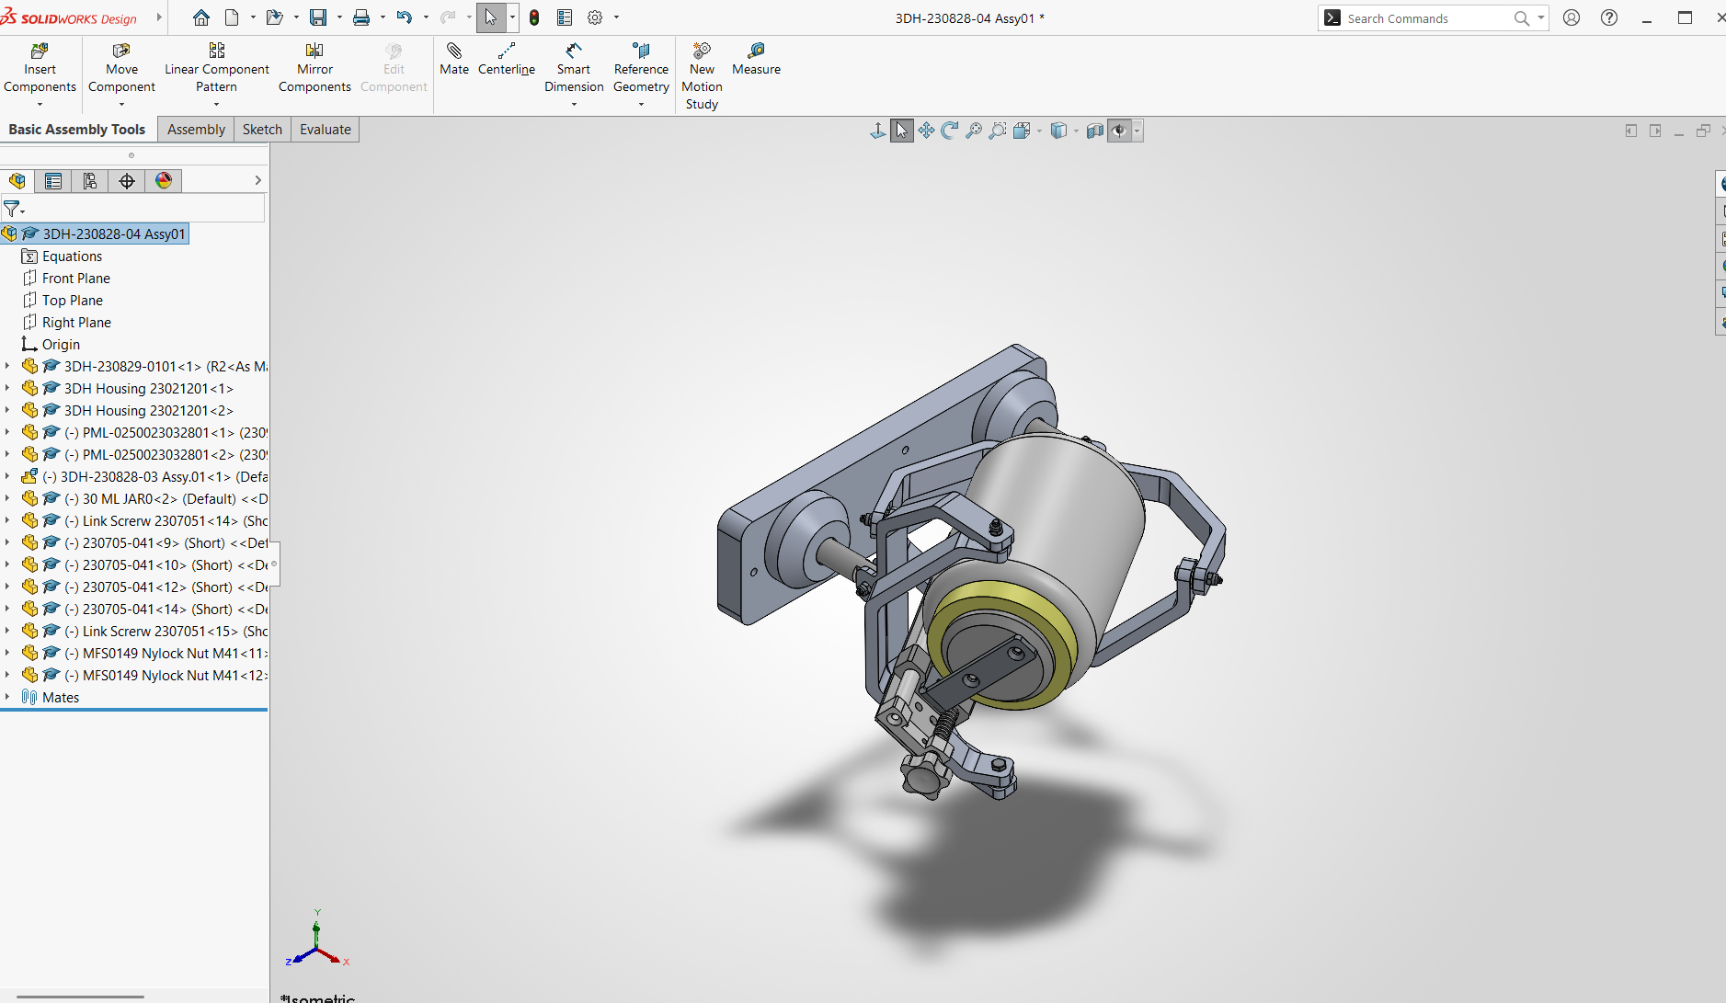
Figure 4.2: CAD assembly of the powder mixer mechanism
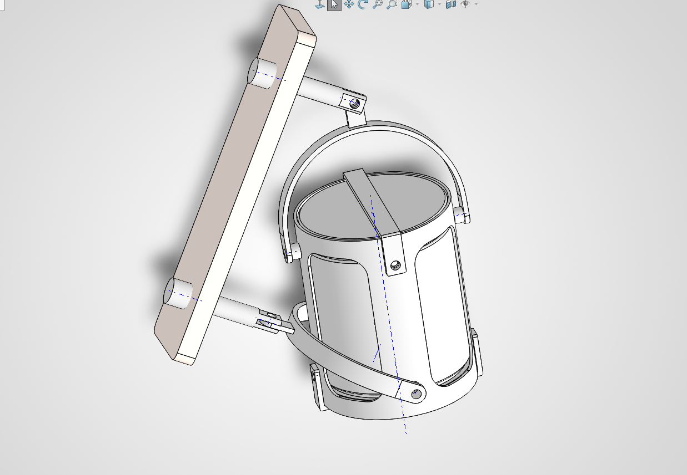
Figure 4.3: CAD view of the rotating cage and linkage arrangement
The mechanisms are based on the Schatz linkage. It features a fixed plate and 5 moving links; 2 shafts, 2 Y links and the cage. The output body is the cage, as the jar is placed inside of it. These links are joined together in one closed loop by six revolute joints (plate, shaft 2, Y link, cage, Y link, new shaft 1 and back to the plate).
The Schatz chain of Section 2.5 is this. Earlier and the new model in ANSYS are shown in figure 4.1. The previous version had two additional links between the shafts and the cage. They joined them together and left the alignment which produced the dead-centre regions. The new model has all the Y links directly connected to the cage. There are two support parts that remain firm with the cage.

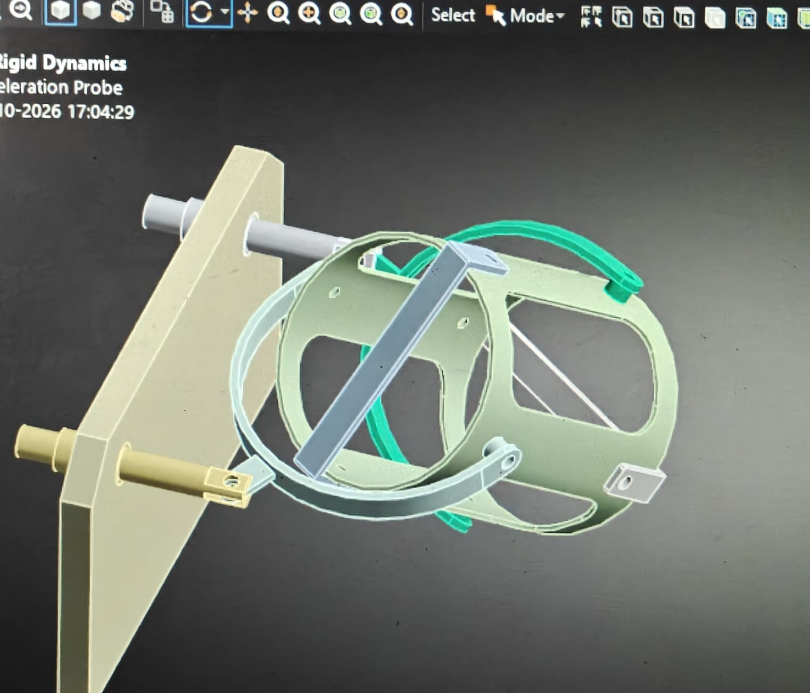
Figure 4.1: ANSYS model views: (a) earlier mechanism, (b) modified mechanism

The rotational velocity is constant at 1.57 rad/s. This is approximately a 15 rpm. The end time of the analysis is 4.0 s and one full turn of the drive shaft occurs during this time. The input is applied to the revolute joint between the plate and a new shaft 1. For this report the drive angle will be θ = 1.57 t (radians) which is approximately 90° of drive rotation per second of run time.

4.2 JOINT DESIGN

The modified model contains 3 fixed joints, and 6 revolute joints. Only joints kept which the actual mechanism requires. All nine of the joints are detailed in Table 4.1..
Joint | Type | Purpose
Ground to plate | Fixed | Keep the base plate fixed
Plate to shaft 2 | Revolute | Let shaft 2 turn about its axis
Plate to new shaft 1 | Revolute | Let the new shaft turn about its axis (drive joint)
Shaft 2 to Y link 1 | Revolute | Pass motion to Y link 1
New shaft 1 to Y link 2 | Revolute | Pass motion to Y link 2
Y link 1 to cage | Revolute | Move the cage directly
Y link 2 to cage | Revolute | Move the cage directly
Support A to cage | Fixed | Keep the support attached to the cage
Support B to cage | Fixed | Keep the support attached to the cage
Table 4.1: Joint arrangement of the modified model
4.2.1 PURPOSE OF EACH JOINT TYPE:
The plate is fixed to the ground with the fixed joint. It provides the basis for all other motion. The reason that the shaft should turn is a revolute joint between plate and shaft. Prevents translation of the shaft and rotation in one plane. A revolute joint between shaft and Y link allows the link to rotate with respect to the shaft. The revolute joint between Y link and cage allows Y link to alter its angle during the mechanism's operation. If there is a fixed joint between support and cage, the support is considered as a rigid group with the cage. The type of joint should be determined from the physical nature of the job of the connection. Increased joints will not improve the model. If a wrong joint or an added link is used a motion path is created that the actual machine doesn't have.

4.3 DESIGN RELATIONS AND DIMENSIONS
We use the Schatz relations of Section 2.5 to check the main dimensions. The relations are used to relate the dimensions to a length a. They are illustrated in a schematic in figure 4.4. The two revolute joints of each Y link have a center distance of a with the two related revolute joints on the cage. The distance between two of the shafts' axes is Ls. The relation is given by equation (4.1).
Ls = √3 · a ≈ 1.732 a (4.1)
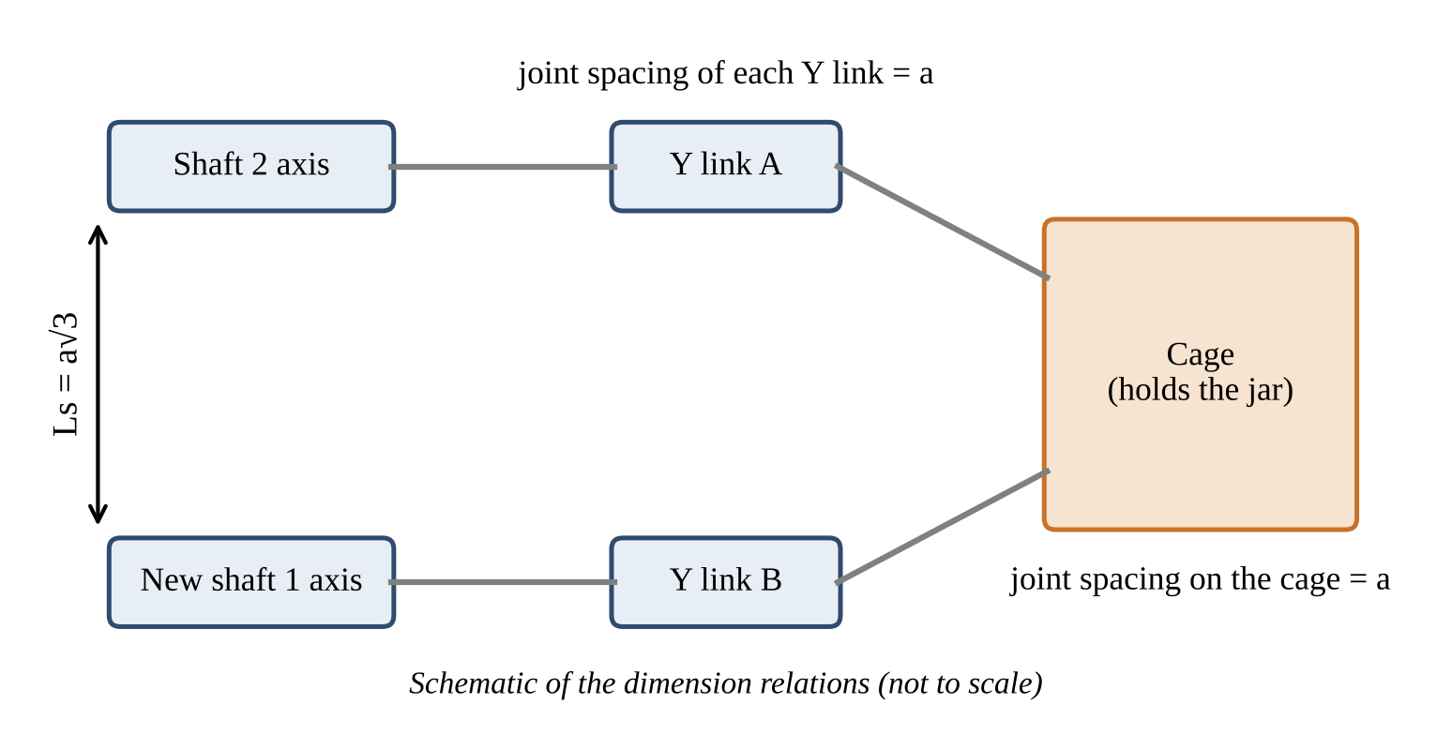
Figure 4.4: Dimension relations of the Schatz linkage used in the design (schematic)
We can test the relation on the CAD data. The ANSYS report gives the centroid of each part. The two shafts are equal parts. Their axes are parallel and their centroids differ only in the Z direction. The centroid distance is 1603.9 − 1361.5 = 242.4 mm. This is the shaft spacing Ls. Equation (4.2) then gives a.
a = Ls / √3 = 242.4 / 1.732 = 139.95 mm ≈ 140 mm (4.2)
The result is a round value. A design value of a = 140 mm gives Ls = 140 × 1.732 = 242.49 mm. The difference from the CAD value is 0.09 mm, which is 0.04%. The shaft spacing of the new mechanism therefore follows the Schatz relation. Table 4.2 lists this check and two more checks.
Item | Value | Comment
Shaft spacing Ls from CAD | 242.4 mm | Centroid distance of the two shafts
a = Ls / √3 | 139.95 mm | Taken as a = 140 mm
Ls for a = 140 mm | 242.49 mm | Difference 0.09 mm (0.04%)
Shaft length | 145 mm | About 1.04 a
Mid-point of shaft centroids (Z) | 1482.7 mm | Equal to plate centroid Z (1482.7 mm)
Y link joint spacing, cage joint spacing | a = 140 mm | Design relation of Section 2.5
Table 4.2: Dimension check of the modified mechanism
The shafts are arranged symmetrically about the plate as the mid-point of the centroids of the shafts is at the centroid of the plate. On both sides the same part of the shaft is used. The two Y's have equal size paths with a symmetrical layout. This makes for a more balanced motion of the cage. It used to be 176.7 mm in shaft spacing. The new shaft spacing is 37% greater. Table 4.3 shows the size and the mass of the two models. The new plate is bigger and heavier and the plate is attached to earth. The mass that is moving is the mass that the drive has to accelerate. It weighs 2.74 kg and in the new model it weighs 10% more, which is 3.02 kg.
Item | Earlier model | Modified model
Bounding box (X × Y × Z) | 240.4 × 200.5 × 313.9 mm | 373.1 × 274.4 × 373.6 mm
Shaft spacing Ls | 176.7 mm | 242.4 mm
Fixed mass (plate and housings) | 3.09 kg | 10.50 kg
Moving mass | 2.74 kg | 3.02 kg
Total mass | 5.83 kg | 13.52 kg
Table 4.3: Size and mass of the two models

4.4 KINEMATIC CORRECTION
There were two major problems with the old mixer. The first was the shaft motion of the orbit. The second was the dead center area. The links found an undesirable alignment around 128° to 135° and 315° to 328° of drive rotation. The two regions are approximately 180° away from each other. The acceleration in the cage was very erratic in the vicinity of these angles, and the old model produced a large "jerk". The redesign change is that two additional links from the chain have been removed. Two Y links have been shortened and now directly attach to the cage. Less number of intermediate joints is present in the shaft to cage path. It also doesn't tie up the links in the dead-center regions. The input continues to exert a torque on the revolute joint between the plate and new shaft 1 about Rotation Z at 1.57 rad/s. There are no model redundancies listed in the solver log and the assembly converges in one iteration. The circular shaft rotation is eliminated. The layout was changed before the input speed was changed. This matters. If it's a difficult position, then lowering the speed can decrease the response, but it will not take away the difficult position. A comparison of the two models is given in Table 4.4.
Parameter | Earlier model | Modified model
Effective bodies in solver summary | 18 | 9
Joint definitions | 22 total; 19 active | 9 total
Revolute joints | 7 | 6
Fixed / weld joints | 15 | 3
Contact regions | 20 defined and suppressed | 8 defined and suppressed
Input speed | −1.57 rad/s | +1.57 rad/s
Extra links in shaft-to-cage path | 2 | 0
Movable links in the Schatz chain | More than five | 5
Table 4.4: Comparison of the earlier and the modified model

4.5 MODELLING ASSUMPTIONS
Every model rests on assumptions. We list ours here so that the reader can judge the limits of the results.
• All parts are rigid. The model does not include deformation of shafts, links, supports or cage.
• All joints are ideal constraints. We do not model clearance or friction.
• The input speed is constant at 1.57 rad/s. We do not use a ramp or an S-curve at start-up.
• The mass and inertia of each part come from the CAD geometry and the density of Structural Steel.
• The contact regions are suppressed in the diagnostic run (Section 5.4).
• The model does not include powder.
These assumptions suit a study of kinematics and of the motion of the cage. They do not suit a study of stress, wear or powder flow.

4.6 CALCULATION METHOD
The ANSYS result sheets give the X, Y, Z and total acceleration at each probe. We use the cage as the physical point. We use the total acceleration column for the scalar jerk. Jerk is the rate of change of acceleration with time. Equation (4.3) gives the definition.
j = da/dt (4.3)
The result points are discrete. We use a central difference between the neighbouring points. Equation (4.4) gives the jerk at point i.
jᵢ = (aᵢ₊₁ − aᵢ₋₁) / (tᵢ₊₁ − tᵢ₋₁) (4.4)
We take the largest absolute value of jᵢ over the full 0 to 4 s result. This value is the peak cage jerk. We use the same method for both models, so the comparison is fair. For the earlier model, the largest value occurs near 1.6841 s. For the modified model, it occurs near 1.4663 s.
The two mechanisms differ in size. For a fair comparison we also use a size-normalised form. In geometrically similar mechanisms, acceleration grows with Ls ω² and jerk grows with Ls ω³. Equations (4.5) and (4.6) give the normalised values.
a* = a_max / (Ls · ω²) (4.5)
j* = j_max / (Ls · ω³) (4.6)
The old mechanism is not exactly similar to the new one, because it has two more links. We therefore use these values as a check and not as the main result.

4.7 WORKFLOW DIAGRAM
We worked in a fixed order. We checked the kinematics first and the dynamic response second. This order saves time, because a dynamic result is of no use when the motion is wrong. Figure 4.3 shows the steps.
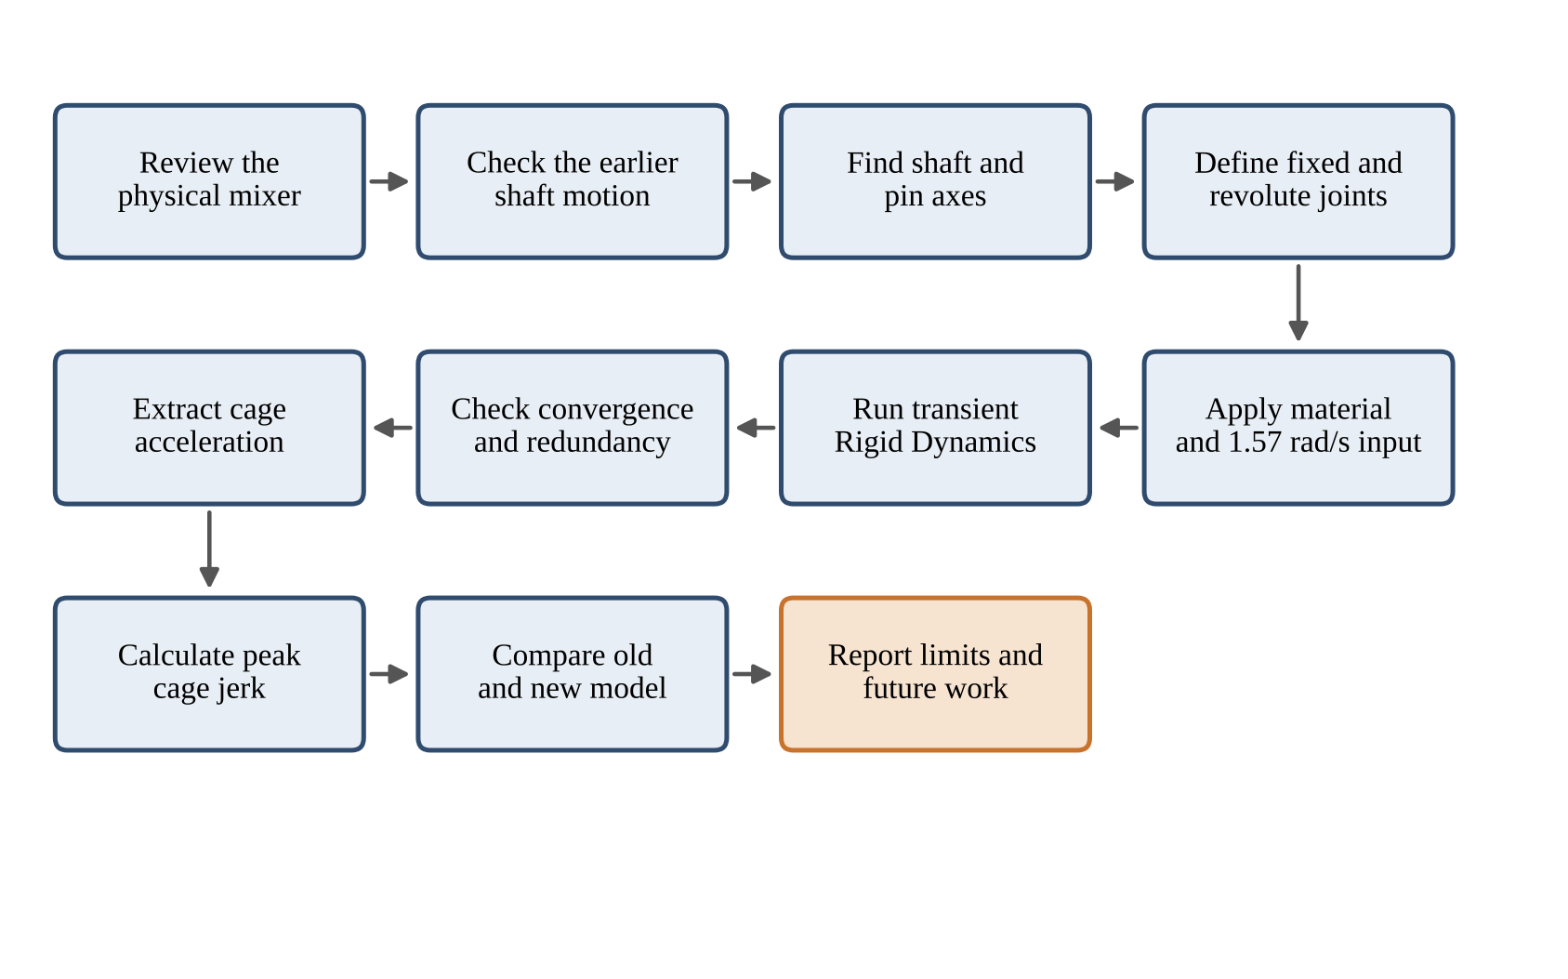
Figure 4.5: Project workflow

4.8 WORK BREAKDOWN STRUCTURE (WBS) CHART
The work is divided into 5 main parts. Each part in figure 4.6 is divided into two tasks. The team carried out the CAD review, the definition of the joint, the set-up of ANSYS, the result check, the computation of the jerk and the final comparison, all together.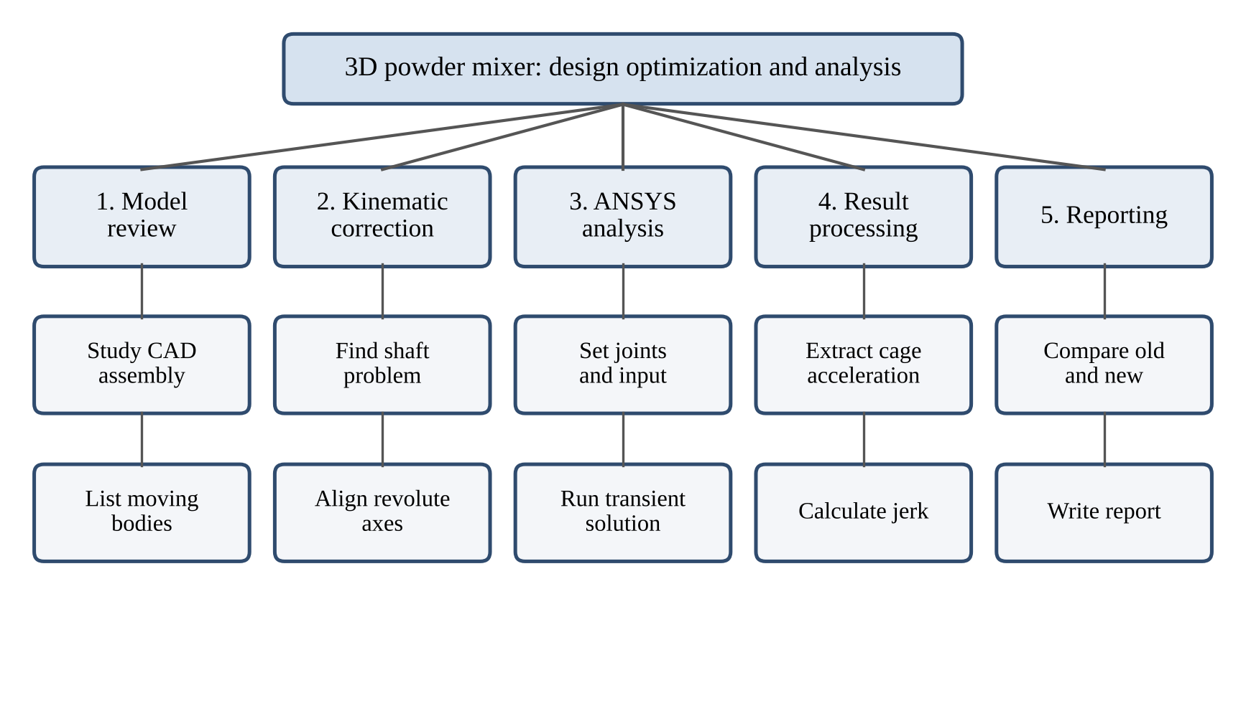
Figure 4.6: Work breakdown structure of the project
REFERENCES
[1] K. Bhoite, G. M. Kakandikar and V. M. Nandedkar, “Schatz Mechanism with 3D-Motion Mixer—A Review,” Materials Today: Proceedings, 2015. DOI: 10.1016/j.matpr.2015.07.003.
[2] M. Zalyubovskyi et al., “Design of a tumbling machine (mixer) using a statically determinate spatial mechanism and determination of rational geometric parameters,” Eastern-European Journal of Enterprise Technologies, Vol. 1, No. 7(139), 2026.
[3] R. L. Norton, Design of Machinery, McGraw-Hill, 5th Edition, 2012.
[4] ANSYS, Inc., ANSYS Mechanical Enterprise 2026 R1, Rigid Dynamics documentation.
[5] Project ANSYS Rigid Dynamics reports of the old and modified mixer models, St. John College of Engineering and Management, Palghar, 2026.

REPORT ON PRESENT INVESTIGATION
The investigation uses two ANSYS Rigid Dynamics reports. One report belongs to the earlier mixer. The other belongs to the modified mixer. Both runs cover a 4 s transient period. Both use an input of 1.57 rad/s in magnitude. The reports contain the full acceleration-time data, and we use this data for all plots and calculations in this chapter.

5.1 PROPOSED SYSTEM
The proposed system is the modified mechanism together with the method that we use to judge it. The method links the model, the solver and the jerk calculation in one chain.

5.1.1 ALGORITHM AND PROCESS DESIGN
We use the following procedure to get the peak cage jerk of one model.
1. Import the CAD assembly into ANSYS Rigid Dynamics.
2. Define the joints from the physical function of each connection.
3. Apply the rotational velocity to the drive joint.
4. Run the transient solution for 4 s.
5. Check the solver log for convergence, redundancy, rejected steps and discontinuities.
6. Export the total acceleration of the cage against time.
7. Calculate jᵢ with Equation (4.4) for each point.
8. Convert time to drive angle with θ = ωt and mark the dead-centre windows.
9. Take the largest absolute value of jᵢ as the peak cage jerk.
We repeat the same steps for the earlier model. Then we compare the two sets of results.

5.1.2 BLOCK DIAGRAM OF PROPOSED SYSTEM
The modified mechanism is represented as a series of bodies and joints in Figure 5.1. The revolute joints are represented by solid lines. The one where there's a dashed line is a fixed joint. Labels R1 to R6 and F1 to F3 are in the same sequence as that shown in Table 4.1. The drive joint is R2. The closed loop of the Schatz chain is the six revolute joints.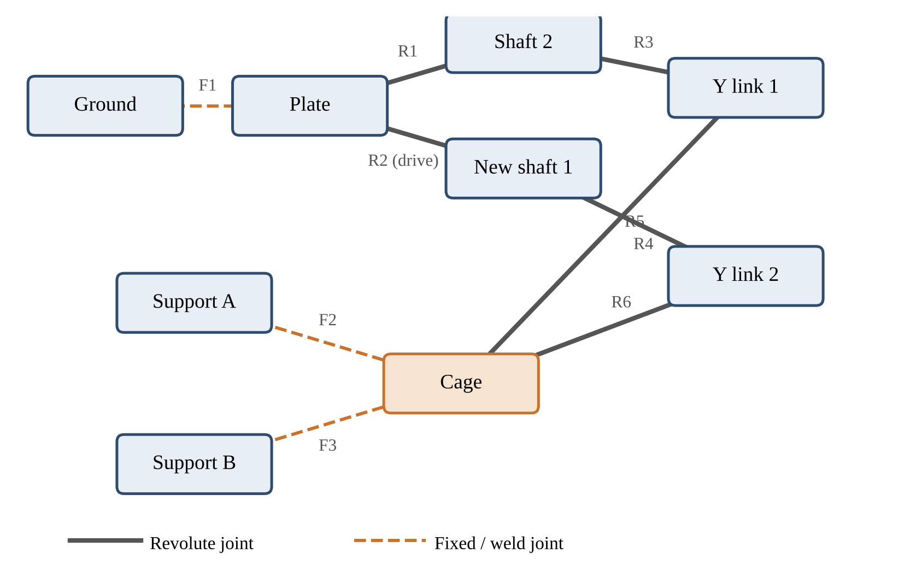
Figure 5.1: Block diagram of bodies and joints in the modified mechanism

5.2 IMPLEMENTATION

5.2.1 ANSYS MODEL SETUP
The modified model is set up in Table 5.1. There are 8 active geometry bodies in the model. The body count is based on the solver summary.
Parameter | Value
Analysis | Transient / ANSYS Rigid Dynamics
Geometry | Parasolid CAD import
Bodies | 8 active geometry bodies; 9 effective bodies
Joints | 6 revolute + 3 fixed
Material | Structural Steel
Input joint | Revolute: plate to new shaft 1
Input direction | Rotation Z
Input speed | 1.57 rad/s
End time | 4 s
Table 5.1: ANSYS setup of the modified model

5.2.2 TRANSIENT SETTINGS
The transient settings are given in Table 5.2. The auto time stepping is turned on. The solver options are program controlled in the setup and the solver log reports on the Runge-Kutta 4 method [1]. The type of correction in the log is pure kinematic.
Setting | Value
Number of steps | 1
Step end time | 4 s
Auto time stepping | On
Initial time step | 0.01 s
Minimum time step | 1 × 10⁻⁷ s
Maximum time step | 0.05 s
Store results at | All time points
Time integration | Program controlled (RK4 in solver log)
Correction | Program controlled (pure kinematic in log)
Table 5.2: Transient analysis settings

5.2.3 OUTPUT OF THE ANALYSIS WITH DESCRIPTION
The total accelerations of the two models in the cage are plotted as functions of the drive angle in Figure 5.2. The grey bands are the dead centre windows of the previous mechanism. The previous model has two peaks, one in each of the window regions. The largest value is about 2597.9 mm/s² at 137.4°, and the second peak is at about 312.2°. There are also two peaks in the modified model, although they are not as high or tall. The largest value is about 1335.0 mm/s² at 118.8°.
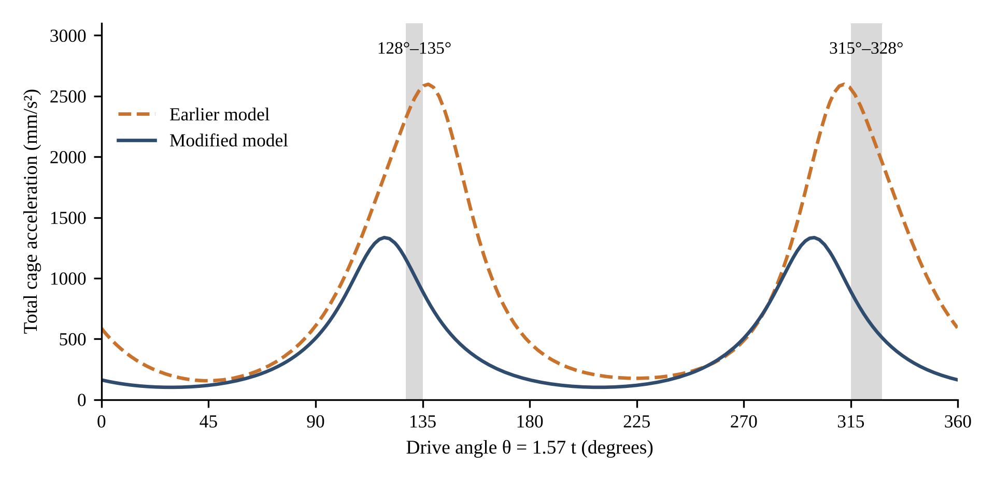
Figure 5.2: Total cage acceleration against drive angle

The cage jerk is displayed in figure 5.3. The first window is used to switch the jerk of the previous model. It is about +4374 mm/s³ at 128° and falls to −7107 mm/s³ at 151.5°. That's a change of over 11,000 mm³/sec over a 24-degree rotation of the drive. The modified model has a slower response time and peak is approximately half.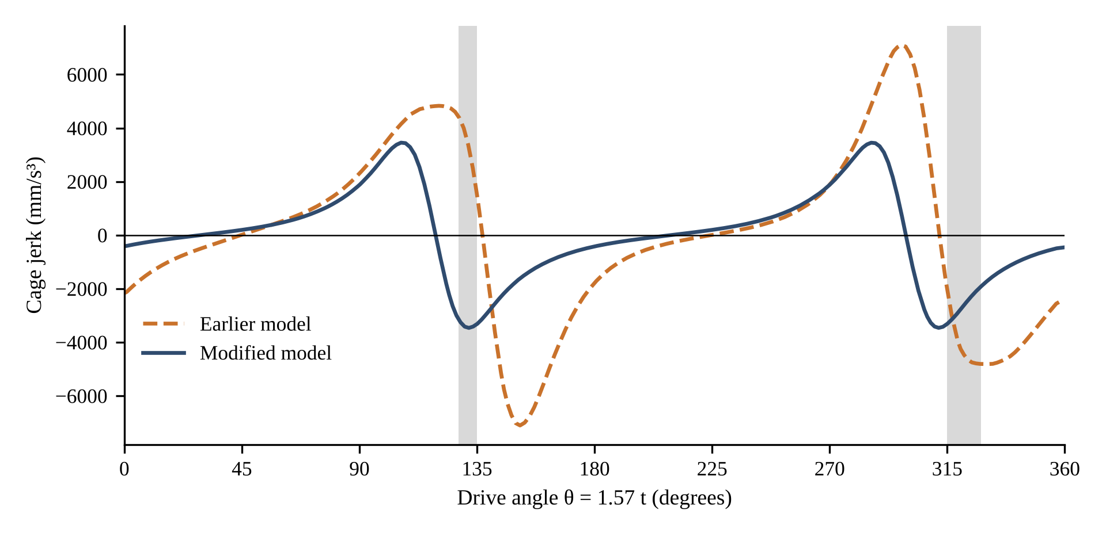
Figure 5.3: Cage jerk against drive angle
The main values are shown in table 5.3. The Jerk values are not based on a probe name; they are based on the total cage acceleration in the central difference.
Quantity | Earlier model | Modified model
Maximum total cage acceleration | 2597.9 mm/s² | 1335.0 mm/s²
Time of maximum acceleration | ≈ 1.5272 s | ≈ 1.3212 s
Maximum absolute scalar jerk | 7107.406 mm/s³ | 3464.010 mm/s³
Time of maximum jerk | ≈ 1.6841 s | ≈ 1.4663 s
Root-mean-square jerk | 3681 mm/s³ | 1955 mm/s³
Mean absolute jerk | 3040 mm/s³ | 1580 mm/s³
Table 5.3: Cage acceleration and jerk
These values give rise to the difference in "Peak Jerk" and the percentage reduction.
7107.406 − 3464.010 = 3643.396 mm/s³ (5.1)
(3643.396 / 7107.406) × 100 = 51.26 % (5.2)
The peak values are shown in both ways in figure 5.4.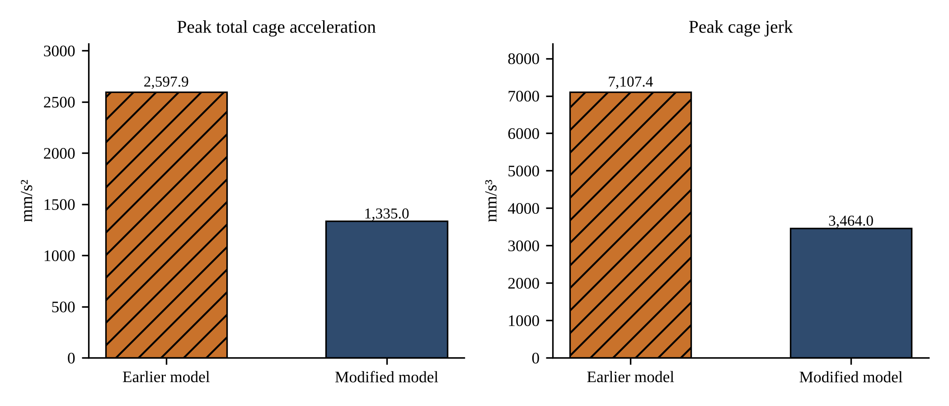
Figure 5.4: Peak cage acceleration and peak cage jerk of the two models

5.3 NUMERICAL STABILITY OF THE MODIFIED MODEL
There is a useful check on the numerical behaviour in the solver log. After one iteration, the assembly came together and there were no model redundancies found by the solver. The main values are given in Table 5.4.
Solver result | Value
Total time steps | 149
Rejected time steps | 0
Discontinuities | 0
Saved configurations | 150
Average time step | 0.0268456 s
Maximum relative error | 0.0152533 %
Position correction iterations | 150
Velocity correction steps | 149
Table 5.4: Solver results of the modified model

The average time step is in good agreement with the run time. The total time is 4 s, distributed over 149 steps, to give approximately 0.02685 s for the end time. There are no steps in the run that were rejected. The solver in the earlier contact diagnostic decreased the time step further and further. This is not the case if the run is being modified. The outcome validates the stability of the model, under the conditions reported.

5.4 CONTACT AND KINEMATIC CHECK
The time step was shortened for the solver in the development of contact-state problems. For this reason, the diagnostic was run again with the problem contact behaviour turned off. The contact regions are suppressed in both reports: 20 in the old and 8 in the modified. Both models thus have the same basis for the comparison. Separation is useful because it's a kinematic question that's the main question. Are all the shafts and links moving in the desired direction? If it is the answer, we can re-establish the necessary physical contacts and then re-test. The last physical model is not the contact-suppressed run. It's a diagnosis condition. We say it again in Ch. 6.

REFERENCES
[1] The computational results are obtained in the software package ANSYS, Inc., ANSYS Mechanical Enterprise 2026 R1, Rigid Dynamics documentation and project output.
[2] Transient simulation logs, 2026, project reports, and results data provided by the project team.

CHAPTER 6

RESULT AND DISCUSSION

The results reveal that there is a distinct mechanical response change between the two different layouts of the elements. The chapter separates out two things. The first will be a direct observation of the simulation. The second one is one that requires further testing.

6.1 KINEMATIC BEHAVIOUR
The first one produced an unwanted circular shaft motion and went through dead-center areas. In this new mechanism, each of the shafts rotates about its own axis. The input is applied to the revolute connection between the plate and new shaft 1. It has a rotation rate of 1.57 rad/s around Rotation Z. All the shafts are connected to Y links and all the Y links directly to the cage.
The cage remains unsaggy with the support parts. The solver doesn't detect any redundancies in the modified model. The same motion type as before. Both models have a range for the angular velocity probe 2 between 0.785 and 3.14 rad/s. This is equal to 4:1 per turn. The new layout thus preserves the 3D nature of the action, and alters the way the cage moves.

6.2 JERK COMPARISON
The comparison between the main points is shown in Table 6.1. The same is represented in figures as shown in figure 6.1 below.
Result | Earlier model | Modified model
Peak cage jerk | 7107.406 mm/s³ | 3464.010 mm/s³
Reduction in peak jerk | — | 51.26 %
Difference in peak jerk | — | 3643.396 mm/s³
Time of peak jerk | 1.6841 s | 1.4663 s
Peak total acceleration | 2597.9 mm/s² | 1335.0 mm/s²
Reduction in peak acceleration | — | 48.61 %
Reduction in RMS jerk | — | 46.9 %
Table 6.1: Result comparison of the two models
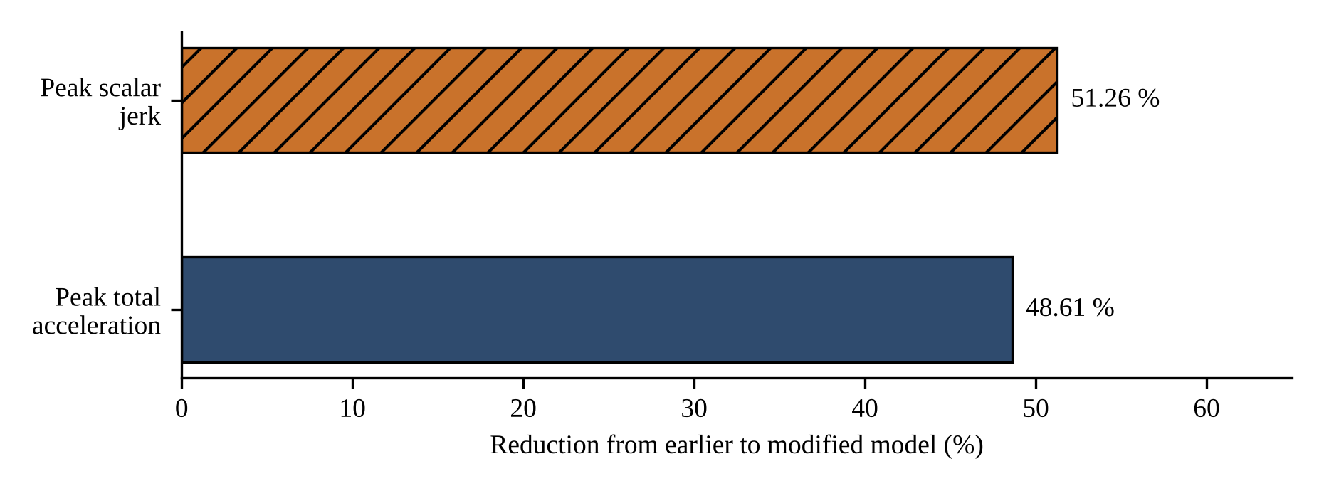
Figure 6.1: Reduction of peak acceleration and peak jerk
The maximum "jerk" of the modified model is approximately half the previous value. The maximum acceleration is also cut in half. Overall, the RMS jerk for the whole cycle decreases by 46.9%. Thus, the gain does not have to be restricted to one stage in the cycle. Let's now consider the windows on the dead center. The largest acceleration and jerk within each window are shown in table 6.2. Increase in the rate of acceleration of the windows is reduced by 56% and 65%. The windows will experience a drop in the jerk of 21% and 31%. The jerk gain within the windows is less than the gain of the peak, due to the fact that the old jerk peaks are located to either 16° behind the first window or 18° in front of the second window. The revised model retains the same angles for its peak usage time of the cycle. The summits have decreased in height.
Window | Result | Earlier model | Modified model | Change
128° to 135° | Maximum acceleration | 2543.0 mm/s² | 1130.2 mm/s² | −55.6 %
128° to 135° | Maximum jerk | 4373.9 mm/s³ | 3464.0 mm/s³ | −20.8 %
315° to 328° | Maximum acceleration | 2512.4 mm/s² | 887.1 mm/s² | −64.7 %
315° to 328° | Maximum jerk | 4809.5 mm/s³ | 3307.7 mm/s³ | −31.2 %
Table 6.2: Cage acceleration and jerk inside the dead-centre windows
Angles in this report will be the drive angles from the beginning of the run and will be defined by θ = 1.57 t. The previous model will have its acceleration cusps at 137.4° and 312.2°. These angles are near the two windows, and are approximately 175° apart. The two peaks of the modified model are at 118.8° and 299.7°, and are approximately 181° apart.
There are two mechanisms which are different in size, one of which a fair reader will ask whether the size causes the change. Normally, a larger mechanism will have a greater acceleration and a greater jerk at the same speed. The new spacing between the shafts is 37% larger, which is detrimental to the new design. The values obtained from Equations (4.5) and (4.6) have been normalized to table size as shown in Table 6.3. They fall by 62.5% and 64.5%. The new model has a moving mass of 10% higher and also the peak jerk is still lesser.
Quantity | Earlier model | Modified model | Reduction
Shaft spacing Ls | 176.7 mm | 242.4 mm | —
a* = a_max / (Ls ω²) | 5.96 | 2.23 | 62.5 %
j* = j_max / (Ls ω³) | 10.39 | 3.69 | 64.5 %
Table 6.3: Size-normalised acceleration and jerk
Jerk is also a measure of force. From Equation (6.1), the rate of change of the inertial force of a moving mass m is the mass times the jerk. The new moving mass is approximately 10% higher and the maximum jerk is approximately 51% less. This means that the inertial force change rate of the moving parts will also be reduced
dF/dt = m · j (6.1)
In both of the runs the maximum jerk occurs after the maximum acceleration. There is a difference of approximately 0.157 s between the two models in the previous case, and approximately 0.145 s in the modified case.

6.3 LIMITATIONS AND ENGINEERING MEANING

The result helps to support kinematic improvement. It does not indicate lower stress, lower bearing load, lower fatigue risk or better powder mixing. These require analyses or tests of their own. This report's " jerk" is a scalar quantity. It is based on the cage acceleration. Differentiating the X, Y and Z accelerations and then adding them together will yield a vector jerk if one exists. We obtained both results with the problem contact regions suppressed. This 51.26% drop is thus valid for the reported simulation condition only. Does not constitute 100% physical approval of the final mixer. The team is required to re-establish the number of contacts and re-run the model before someone is allowed to use the number as a product claim. The study takes place on the basis of rigid bodies. Does not include the elastic deformation of shafts, links, supports and cage. There are differences in size between the two CAD models, as revealed in Table 4.3. This effect is eliminated by the normalised values, but does not get removed. It is important to note that the raw acceleration-time data should remain with the project records and a corresponding value can be traced in this report for each value presented.
The prototype should be tested using the actual jar configuration and actual powder load for the jar. The most effective way of establishing trust in the model is by comparing the measured vibration with the calculation result provided by ANSYS.

6.4 OBJECTIVE-WISE SUMMARY
Each of the objectives of Section 1.3 is connected to the result which addresses (6.4)
Objective | Result | Section
Find the cause of high jerk and dead centres | Two extra links allowed an alignment near 128°–135° and 315°–328° | 1.2, 4.4
Make the new mechanism | Two links removed; Y links joined directly to the cage | 4.1, 4.4
Check dimensions with Schatz relations | Ls = 242.4 mm gives a = 139.95 ≈ 140 mm | 4.3
Correct shaft kinematics | Circular shaft motion removed; no redundancy reported | 4.4, 6.1
Run transient analyses | 4 s runs of both models | 5.2
Compare acceleration and jerk | Peak acceleration −48.61 %; peak jerk −51.26 %; windows −21 % to −65 % | 5.2, 6.2
Check numerical stability | 149 steps; 0 rejected; 0 discontinuities | 5.3
Table 6.4: Objectives and results
All objectives have a result. The last 3 rows have the limits in Section 6.3. Only for the condition of contact suppression the stability is true.
REFERENCES

[2] Total acceleration-time data can be used to calculate cage jerk; [2] 2026 project. The modified run was done with 149-time steps and 4 s of run time. It did not have any steps that were rejected or discontinuities. It is shown that for the analyzed condition, there is an improved kinematic behaviour with a reduced cage response. In order to draw final conclusions about the performance of the machine, testing of the physical prototype is still required.

CONCLUSION AND FUTURE WORK

7.1 CONCLUSION
This project was developed for Custom Capsule Pvt. Ltd. where the aim was to determine the analysis of the 3D powder mixer and optimize its mechanism. The layout of the links was adjusted to reduce the cage jerk, two dead center areas (near 128°–135° and 315°–328° of drive rotation) and a good amount of orbital motion of the shaft. The Y links were directly tied to the cage and two additional links were taken off. New design is based on the Schatz linkage, which is a set of 5 movable links. The growth rate of the main dimensions complies with the Schatz relation Ls = a√3. The CAD shaft spacing is 242.4 mm, and therefore the value of a would be 139.95 mm or 140 mm to the nearest whole value. There are six revolute and three fixed joints in the model. Input speed of = 1.57 rad/s. The solver is not able to detect any model redundancies. The common reference for us was the cage. The maximum cage jerk in the previous model is 7107.406 mm/s³ while the cage jerk in the modified model is 3464.010 mm/s³. This is a reduction of 3643.396 mm/s³, or about 51.26%. The peak total cage acceleration was lowered from 2597.9 mm/s² to 1335.0 mm/s² which was approximately 48.61% less. The size normalized values are more than 62% reduced, but it is larger and with a moving mass 10% greater. The modified run took 149-time steps to complete and run over 4 s. There was no steps or discontinuities rejected. It is observed that the cage response is improved and lower when compared to the condition analyzed for the results. Further tests on the physical prototype are required before definite conclusions can be drawn about machine performance.

7.2 FUTURE WORK
- Make the necessary physical contacts and perform the full model once again. Make sure to use the actual acceleration-time export for the final jerk calculation and retain it with the project records.
- Compute vector jerk (acceleration in the X, Y and Z direction). Also check driven joints and free motion that is not driven before the complete physical model has been finalized.
- To minimize the effect of the different dimensions, compare the old and new mechanisms at the same size. Test ramp/s-curve speed inputs to reduce start up jerk. After the validation of the kinematic model, check the loads, stress and fatigue on the bearings. Perform flexible body structural analysis.
- Perform a test of the prototype using the actual jar and powder load and measure the vibration. Using DEM to investigate powder flow and uniformity of blends with corrected cage motion.
- These steps are not in any particular order. Re-compile the whole model first by restoring the contacts. Any other checks are dependent on that one.
REFERENCES
[1] Project ANSYS Rigid Dynamics, Reports & Final comparison, St. John College of Engineering and Management, Palghar, 2026.
[2] ANSYS, Inc. is the manufacturer of ANSYS Mechanical Enterprise 2026 R1.

APPENDIX A

KEY ANSYS DATA AND RESULT SHEETS
The key ANSYS data of both models are listed in Table A.1. The values are from the ANSYS reports provided or from the project's calculation. The comparison between the jerks is based on the cage, not the probe number.
Item | Earlier model | Modified model
Geometry source | Final mixer CAD assembly | New mixer CAD assembly
Material | Structural Steel | Structural Steel
Input magnitude | 1.57 rad/s | 1.57 rad/s
Input direction | Negative Z | Positive Z
Joint count | 22 total / 19 active | 9
Revolute joints | 7 | 6
Fixed / weld joints | 15 | 3
Saved time points | 155 | 150
Peak total cage acceleration | 2597.9 mm/s² | 1335.0 mm/s²
Peak cage jerk | 7107.406 mm/s³ | 3464.010 mm/s³
Time of peak jerk | 1.6841 s | 1.4663 s
Extra links in shaft-to-cage path | 2 | 0
Table A.1: Key ANSYS data
Figure A.1 and Figure A.2 show the complete ANSYS result sheets of the two models. These are the cages used for the cage data in Chapter 5.
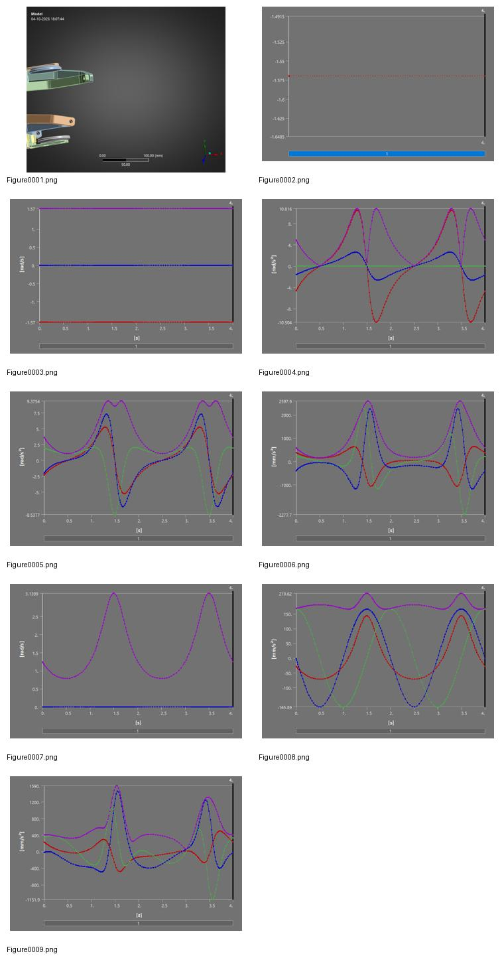
Figure A.1: ANSYS result sheet of the earlier model

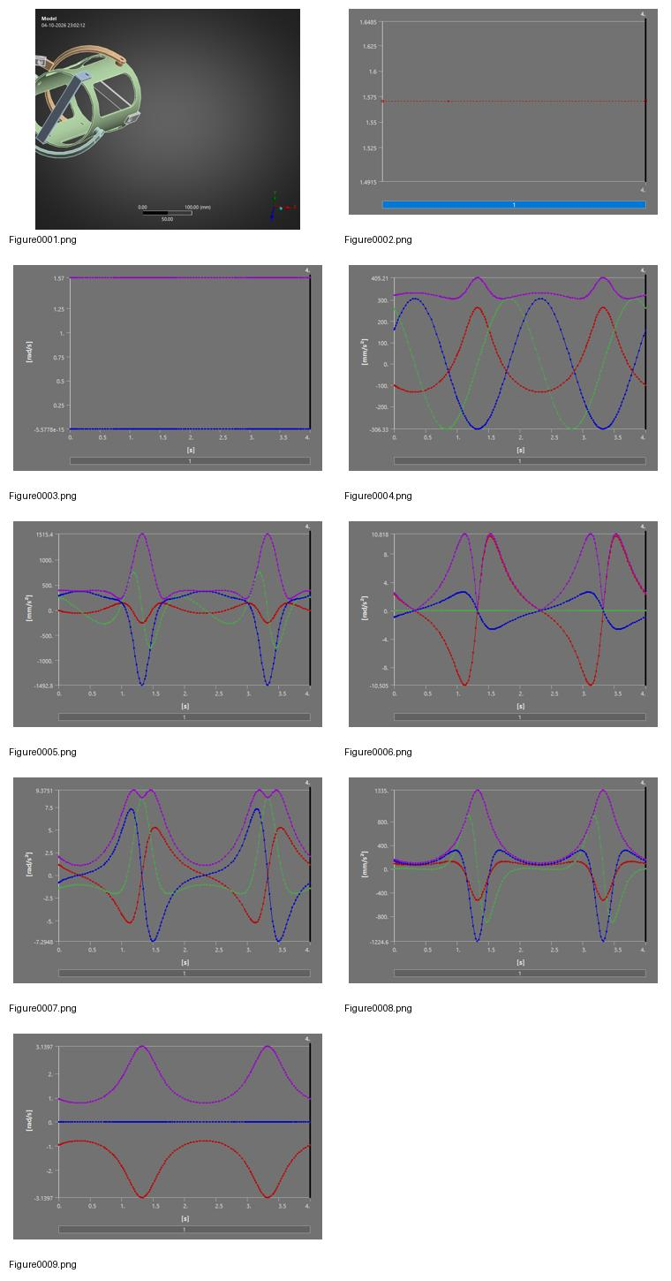
Figure A.2: ANSYS result sheet of the modified model
REFERENCES
[1] All the reports are based on the project ANSYS Rigid Dynamics at the old and modified mixer models presented by the St. John College of Engineering and Management, Palghar, 2026.

APPENDIX B

GLOSSARY OF TERMS
This glossary gives short definitions of the technical terms that the report uses.
Term | Meaning
Acceleration | The rate of change of velocity.
Dead centre | A position in which links line up and the driving link cannot control the driven link well. Also called a singular position.
Degree of freedom (DOF) | One independent way in which a body or a mechanism can move.
Discontinuity | A sudden jump in a result that the solver finds during a run.
Fixed joint | A joint that gives no relative motion between two bodies.
Jerk | The rate of change of acceleration.
Model redundancy | A constraint that repeats another constraint in the model.
Probe | A result item that records one quantity at one location in ANSYS.
Revolute joint | A joint that allows one rotation about one axis.
Rigid body | A body that does not change its shape.
Schatz linkage | A spatial closed chain of revolute joints, with five movable links, that gives a 3D motion.
Time step | The interval of time between two calculations of the solver.
Transient analysis | An analysis that calculates the response of a system as time passes.
Table B.1: Glossary of terms

PLAGIARISM REPORT